**Skills for the future and VET in the world the focus of European vocational skills week 2019**

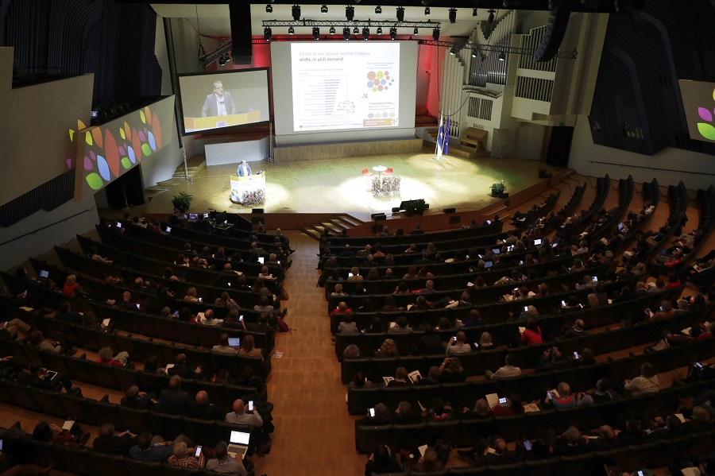

**Image copyright:**

© European Commission, 2019

**As jobs and ways of working transform, so does the emphasis on skills and learning, said Cedefop Executive Director Jürgen Siebel in a keynote speech at the European vocational skills week (EVSW) 2019 main events in Helsinki.**

Adaptability to change is the skill most in demand, according to Cedefop’s analysis of online job vacancies, he added.

The EVSW 2019, organised by the European Commission with Cedefop as a partner, took place between 14 and 18 October across Europe and beyond. Over 1 400 events in 45 countries reached 2.5 million people.

Mr Siebel was speaking at the ‘vocational education and training (VET) for all, skills for life’ conference. He noted that digital transformation breeds digital skill gaps, potentially affecting one in three workers, therefore sound digital and technological literacy is key to social and economic participation, adding: ‘Building the skills for tomorrow will require deep learning from one another, will impact on VET and require policy choices.’

Outgoing European Commissioner for Employment, Social Affairs, Skills and Labour Mobility Marianne Thyssen said at the ‘VET in and for the world’ conference that ‘we decided to open the VET week to the world because we all face the same challenges; wherever we are, our people and our companies need the right skills.’ At the closing event, she announced that the 2020 edition of the EVSW main celebrations will be held in Berlin (9-13 November), in the context of the German EU Presidency.

Finnish Education Minister Li Andersson argued that the most important skill we learn at school is the ability to learn. Everybody needs a strong set of basic skills, and we need a comprehensive system of lifelong learning.

Elke Büdenbender, one of the week's ambassadors, a judge and the spouse of Germany’s Presidency Frank-Walter Steinmeier, said: ‘We need to support initiatives against gender stereotypes. Unfortunately, female students in mathematics, computer science and technology are still a minority. But we cannot afford to miss out on even a single talent in Europe.’

**Cedefop input**

A team of Cedefop experts participated actively in the Helsinki events, moderating workshops or making presentations of the agency’s work.

Head of Department for VET Systems and Institutions Loukas Zahilas represented Cedefop with expert Jens Bjornavold at the interagency group meeting, and was a panellist at a session on the role of TVET in the sustainable development goals.

Tina Bertzeletou organised a meeting of Cedefop’s community of learning providers to discuss results and development of knowledge-sharing for the future quality of VET. The three working groups agreed on the steps forward.

Irina Jemeljanova moderated a session on the changing role of teachers and trainers, with Irene Psifidou presenting Cedefop’s VET toolkit for tackling early leaving from education and training. Lidia Salvatore spoke at the *European alliance for apprenticeships* meeting and moderated a session on ‘Services 4.0: innovation for workforce upskilling and reskilling’. Pedro Moreno da Fonseca participated in a panel on the role of EU agencies and social partners in lifelong guidance practice and policy development. Jens Bjornavold moderated a session on international qualifications and standards where George Kostakis presented Cedefop’s relevant work.

Mr Kostakis also made a presentation in a session on evidence-based and future-oriented policy-making for VET and adult learning. Dmitrijs Kulss and Iraklis Pliakis presented remotely the findings of Cedefop's key competence study to the ET2020 working group on innovation and digitalisation.

The Cedefop Executive Director outlined some of the agency's activities and gave an impulse statement in the workshop on financing continuous learning and incentivising the individual in VET. Ms Schmid was rapporteur from a DGVT break-out session and chair of a round table in the discussions, co-shaping also the messages from this table in the vocational excellence workshop of VET for all.